**Social Inclusion (ISSN: 2183-2803)  
Year, Volume, Issue, Pages X–X  
DOI: 10.17645/si.vXiX.2035**

Article

**The Relationship between Educational Pathways and Occupational Outcomes at the Intersection of Gender and Social Origin**

Author(s)

**Abstract**

We analyse the effects of social origin and gender on educational pathways and subsequent labour market outcomes. We apply sequence analyses to model the educational trajectories and conduct regression analyses to determine the effects on the individuals own social status and the salary at labour market entry. Our results show, first, that, controlling for reading and mathematics/science skills, educational pathways differ by social origin and gender. Men and pupils with a lower socioeconomic background are overrepresented in vocational education, whereas women and pupils with more a privileged socioeconomic background more often pursue general and academic tracks. Second, these different trajectories lead to unequal occupational status and income. Net of the educational trajectory also significant effects of gender and social origin remain. Further, we find a class pay gap that is especially pronounced for women.

**Keywords**

Educational Inequality; Gender; Sequence Analyses; Social Origin; Wage Gap

© YEAR by the author(s); licensee Cogitatio (Lisbon, Portugal). This article is licensed under a Creative Commons Attribution 4.0 International License (CC BY).

**1. Introduction**

Unequal opportunities for attaining higher education or a decent salary can intersect and combine to cumulative (dis‑)advantages. When Ralf Dahrendorf wrote his “plea for an active education policy” under the title “education is a civil right” (Dahrendorf, 1965) in the 1960ies, he mentioned three main groups of children that are being underrepresented in secondary school: rural children, working-class children, catholic children (with some reservations), and girls. While Dahrendorf was aware that these groups may intersect, he did not further investigate this circumstance. Nevertheless, the artificial figure of the “catholic working class girl from the countryside” was born (Allmendinger, Ebner, & Nikolai, 2010; Becker, 2007; see also Peisert, 1967). With social changes, such as, for example, the expansion of education, postindustrialisation, increasing globalisation and (at least in legal terms) gender equality, the symbolic figure of cumulative educational disadvantage has transformed from the “worker's daughter” to the “migrant son” (Geißler, 2005). Indeed, girls caught up with boys in their educational attainments and even start to outnumber them in terms of higher educational qualifications (C. Buchmann & DiPrete, 2006; DiPrete & Buchmann, 2013). However, this should not hide the fact that first, improved education has not translated into equal work opportunities for men and women (Blau & Kahn, 2017; Charles, 2011) and second, persons with a lower socioeconomic family background may not only be disadvantaged in the education system, but also in the labour market (Mood, 2017).

In the current research, we are interested in how social origin and gender interact and shape the early life courses from the end of compulsory school to the first years in the labour market. The question we try to answer in this article is, whether there are differences in educational pathways and in the early working life, namely occupational status and income, by social origin and gender jointly. Our main interest lies in describing the overall relationship between social origin and gender, and the educational trajectories as well as subsequent labour market outcomes, rather than in identifying causal mechanisms that might be responsible for these differences. Theoretically, we combine two lines of argumentation: First, we draw on the literature on primary and secondary effects of origin (Boudon, 1974; Bourdieu & Passeron, 1971; Breen & Goldthorpe, 1997). Second, we complement this with theories on gender segregation in education and employment (Charles & Bradley, 2002, 2009). Throughout the paper we adopt an intersectional approach, that considers different dimensions of social inequality simultaneously (McCall, 2005). For our analyses, we draw on a unique longitudinal dataset that covers Swiss adolescents from the moment they took the PISA-Test in the year 2000 until 2014, when they were around 30 years old. To take advantage of the panel data, we model the pathways of post-compulsory education using sequence analysis. Our article has two main strengths compared to previous research, it gives a more complete overview over the entire post-compulsory educational trajectory and the early years of the working life and it systematically incorporates an intersectional approach by analysing gender and social origin jointly.

**2. Previous Research and Theoretical Background**

Research in educational inequalities is often based on the theories ofprimary and secondary effects of social origin, initiated by the seminal work of Boudon (1974) and further developed by many others (Breen & Goldthorpe, 1997; Erikson & Jonsson, 1996). Briefly, primary effects indicate that children from different social origins differ in their school performance. Children originating in the higher social classes generally perform better in school, because they have at their disposal more economic and cultural resources at home that lead to more education specific support (Becker & Lauterbach, 2010). In addition to these primary effects, children from higher social origin reach higher levels of educational attainment, even if they perform equally as their counterparts from lower social origin. In the literature, these secondary effects of social origin have been explained by differential decisions based on rational cost-benefits calculations. According to the relative risks aversion model (Breen & Goldthorpe, 1997), the main aim is to obtain as much education as is necessary to avoid downward mobility (compared to the social position of the parents). More cultural approaches indicate that different educational decisions by social class could also be due to subcultural norms concerning the value of education, caused for example by class-specific socialisation or by a desire for conformity (Paulus & Blossfeld, 2007).

A few studies have taken an intersectional approach to analyse effects of different ascriptive characteristics on school performance (primary effects). They mainly find that especially boys with a low socioeconomic family background perform worse at school (Entwisle, Alexander, & Olson, 2007; Glaesser & Cooper, 2012). Strand (2014) does not find any interactions between socioeconomic status and gender. Gottburgsen and Gross (2012) additionally find heterogeneous effects, depending on whether reading or mathematics skills are concerned (see also Becker & Müller, 2011). Intersectional approaches assessing secondary effects are less common. Breen, Luijkx, Müller, and Pollak (2009), as well as Becker and Müller (2011) take a historical approach and try to assess how educational expansion and increasing gender equality in education interact. They show that gender and class differences in educational inequality have declined. While Becker and Müller (2011) find that gender differences in class inequalities have changed over time, according to Breen et al. (2009) they have remained rather stable.

Primary and secondary effects of social origin do not only influence the level of education one attains, but there is also a horizontal dimension to it. In other words, within a certain level of education, students from different class backgrounds do not necessarily study the same subjects (Becker, Haunberger, & Schubert, 2010; Reimer & Pollak, 2005; van de Werfhorst, 2002). Such horizontal differences are relevant because they may translate to vertical stratification as fields of study differ in terms of subsequent labour market opportunities (Reimer & Pollak, 2005). Theoretically, several mechanisms can lead to these differences. According to van de Werfhorst (2002) there is a cultural aspect of intergenerational transmission. Children get more information on the fields of study of their parents and are therefore more likely to choose a similar subject. Reimer and Pollak (2005) indicate further aspects that may lead to different choices of field of study by social origin that are drawn from rational choice considerations, namely the perceived difficulty of a subject, the study duration, subsequent job security and opportunities to attain a favourable class position and achieve high incomes (Reimer & Pollak, 2005, p. 7). For a more detailed discussion of primary and secondary effect on the choice of subject of study, see also Becker et al. (2010).

Glauser (2015) discusses how the mechanisms of primary and secondary effects shape gender differences in educational outcomes. Primary gender effects emerge because girls generally show a greater willingness to learn, have a more positive attitude towards school than boys and, as a result, achieve better school grades on average (Glauser, 2015, chapter 4.3.2). Secondary effects can be identified by the fact that girls are more likely than boys to choose more demanding training paths at the same levels of performance. In the Swiss education system, this happens mainly because they have restricted career prospects within vocational education that is historically rooted in the highly gender segregated manufacturing and industrial sector (Imdorf & Hupka-Brunner, 2015; Imdorf, Sacchi, Wohlgemuth, Cortesi, & Schoch, 2014). Hence, for boys, the vocational education is more attractive because they find a wide range of male typical occupations that offer good career prospects, including, for example, opportunities of further education (Glauser, 2015).

Ultimately, we assume that gender differences in educational pathways are mainly due to horizontal segregation and that this can lead to vertical stratification. However, we believe that horizontal segregation in vocational education and fields of study is not merely due to differential career prospects for men and women, but that it is rooted in a very persistent “gender-essentialist ideology” (Charles & Bradley, 2009). This gender ideology adheres to beliefs in differences between men and women, in how they are and how they ought to be (Eagly & Sczesny, 2008). Accordingly, social roles, such as, for example occupations, are gendered, too. That is, technical or manual occupations, as well as leadership positions are being considered as more typically masculine, whereas caring or teaching domains are seen as intrinsically feminine. According to the role congruity theory (Eagly & Diekman, 2006; Eagly & Karau, 2002), people try to act in manners that are consistent to their gender, because if they do not, they may face negative consequences. This gender-essentialist ideology is rooted very deeply. For example, Schwiter et al. (2014) have shown that boys and girl develop occupational preferences and aspirations that correspond to their own gender in a very early age (see also M. Buchmann & Kriesi, 2012).

Whether these gender stereotypes differ by social class is less well researched (for a detailed account of gender and class stereotyping in an elite labour market see Rivera & Tilcsik, 2016). England (2010) argues that as long as upward mobility (or at least avoidance of downward mobility) is possible within ones gender typical occupations, people will tend to continue to choose a field of study or a job that corresponds to their own gender. Consequently, for the lower and middle class women it is easier to remain in a gender segregated female job, while for upper class women this is less true, as female typical jobs are often lower in status (England, 2010). This means that an interplay between gender and social origin shapes young adults school trajectories and subsequently influences their labour market opportunities.

In sum, although the mechanisms might not be the same, choice of field of study simultaneously differs by social origin and by gender. So far, analyses mainly in gender sociology and labour economics have focused on horizontal gender segregation, while research in educational sociology has dealt with both aspects, gender segregation and segregation by parental status, but not conjointly. We therefore attempt to consider both, gender and social stratification in the educational trajectory, including aspects of horizontal and vertical segregation.

Vocational education plays an important role in Switzerland's dual training system. It offers different possibilities to access tertiary level education, such as, for example, professional schools, universities of applied sciences and in some cases universities. However, the ideal route to university continues to be via high school. For more detailed information on the Swiss educational system see for example Imdorf, Koomen, Murdoch, and Guégnard (2017), Glauser (2015, chapter 2.1) or Imdorf and Hupka-Brunner (2015).

In line with the theories sketched above and due to the specificity of the Swiss educational system, it can be assumed that the higher the socioeconomic status of the parents, the better the school performance of children and the more likely it is that they follow an academic educational trajectory. We believe that this is more the case for girls than for boys, because vocational education, including further training in male dominated occupations offers more beneficial educational and subsequently job opportunities for boys than for girls. Access to female typical jobs in the health sector and teaching is provided via general schools on secondary level.[1]

**3. Data and Methods**

*3.1. Data*

We use the Swiss data from PISA (Programme for International Student Assessment) 2000 and the subsequent panel data of TREE (Transitions from Education to Employment), which is a follow up panel of students having participated in the PISA 2000 survey, consisting of 9 waves, collected between 2001 and 2014. We only consider persons who participated in each of the nine waves. This considerably reduces our sample but is necessary to conduct the sequence analysis.

To analyse students’ skills in reading, mathematics and science, we used the “Warm estimate” from the PISA 2000 database. These scores consist of the weighted averages of correct answers to all questions of a specific category. The weighting procedure follows Warm’s (1989) method of a weighed likelihood estimate (WLE). The main focus of the PISA 2000 tests were the reading skills. All students answered the reading assignments, but half of them answered only either the mathematics or the science tasks. To reach a bigger number of cases we combined the two scores of mathematics and science. We used the scores from the test taken. If both were taken, we calculated the mean score of the two tests. A further variable used from the PISA database is the socioeconomic status of the parents. We use the international socioeconomic index (ISEI), either from the father or the mother, depending on which one is higher. This score is based on the students information on parents occupation (Adams & Wu, 2003).

In each of the nine cross-sectional waves the school and work situation of the participants was recorded in detail. Additionally, TREE provides an episodic dataset for the job episodes 2003-2014 and a beta version of educational episodes 2010-2014. For the time before 2010, we had to rely on cross-sectional information on the individuals’ educational status to construct the episodes. In a further step, we merged the datasets of the education and the job episodes and constructed a variable called “state” that indicates the education or job state of each episode and has the following values:

* Vocational education and training on secondary level (e.g. apprenticeship)
* Upper secondary specialized school (e.g. schools that prepare for further education, mainly in the health sector)
* General secondary education (e.g. baccalaureate school)
* College of higher education (e.g. technical school, upper vocational school)
* University of applied sciences
* University of teacher education
* University
* Advanced studies (Certificate / Diploma / Master of advanced studies)
* Other educations or trainings (e.g. internships, language schools)
* Employed
* NEET (neither in education nor employed)

Our main outcome variables are the individuals own socioeconomic status and their income in 2014, at around age 30. To measure the socioeconomic status we constructed the ISEI from the ISCO-08 that is provided in the TREE data. We use the last available observation, which is 2013 or 2014 for around 95% of the individuals. In the regression models, we add a control variable that indicates whether the measurement of the ISEI is current or not. The income variable displays the gross monthly salary in 2014 in Swiss francs, standardised on a fulltime position (max. 42 hours per week; for more details see Gomensoro et al., 2017, p. 33), and logged when used in regression models. Some of the respondents have several jobs at the time. As there is no clear information in the data, on which is the most important job, we chose to consider the job with the highest income. **Table 1** (in the appendix) displays the (weighted) frequencies, means (or proportions if the variable is binary) and standard deviations of all used variables for men and women separately. Our sample consists of 907 men and 1353 women having participated in each wave.

*3.2. Methods*

Empirically, we apply sequence and regression analyses. From the episodic data, we constructed sequences with monthly information on the education or employment status of each individual. To make sense of the multitude of sequences, we form clusters of sequences using the dynamic hamming procedure (Lesnard, 2010), which is a variant of optimal matching. It is especially suitable when all sequences have the same length. The optimal matching procedure compares each sequence with every other and calculates the distances between them. The least number of transformations necessary to match the two sequences determines the dissimilarity between them (see for example Halpin, 2010; Lesnard, 2006; Lesnard, 2010). From this procedure results a distance matrix that contains distances between all individual sequences. In a second step, this distance matrix is being used for cluster analysis. Similar sequences will then be grouped together in clusters of educational trajectories (e.g. Brzinsky-Fay & Kohler, 2010). We performed the calculations with the SADI package for Stata (Halpin, 2017).

To test our assumptions we conduct several regression models. First, we estimate linear regressions to test the primary effects of social origin on reading and mathematics/sciences skills. To take an intersectional approach, we insert an interaction term of parental ISEI and gender. Second, we applied a multinomial logit model to estimate the probability of pursuing a particular educational trajectory (including a model net of reading, mathematics/science skills). Third, we conduct again linear regressions to estimate the effect of social origin and gender on the persons own social status and their income at age 30. We estimate an additional model, controlling for the educational trajectory. Finally, we also estimated the effects of the educational trajectory on own status and salary. For all analyses, we use the appropriate survey weights taking into account the clustered sampling procedure and panel attrition (see Sacchi, 2011).

**4. Empirical Findings**

The first step of our analyses addresses the primary effects at the intersection of social origin and gender. Consistent with the existing literature we find differences in school performance (see Figure 1 and Table 2 in the annex). Pupils coming from families with a high socioeconomic status tend to perform better than pupils from less affluent families do. In addition, we confirm previous findings, showing better reading skills of girls and better mathematical and science skills of boys. Further, we find strong interaction effects between social origin and gender: Mainly the boys coming from families with a lower socioeconomic status are having difficulties accomplishing the reading tasks, resulting in a curvilinear, inversed U-shaped pattern for boys, while a generally flatter and linear trend can be found for girls. In mathematics and science, we find a gender difference only for the pupils in the middle range of the parental ISEI, with boys outperforming girls.

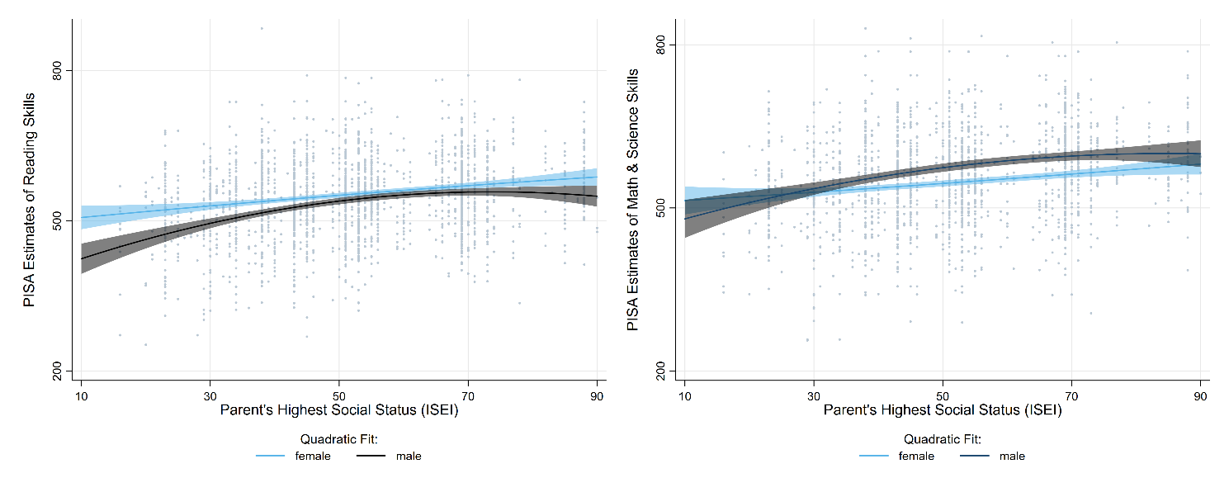**Figure 1:** Effects of parental social status (ISEI) on reading, mathematics/science skills

Next, the sequence and cluster analyses determine the educational trajectories of our sample. We found a solution of five clusters to be appropriate. The chronogram in Figure 2 displays them.

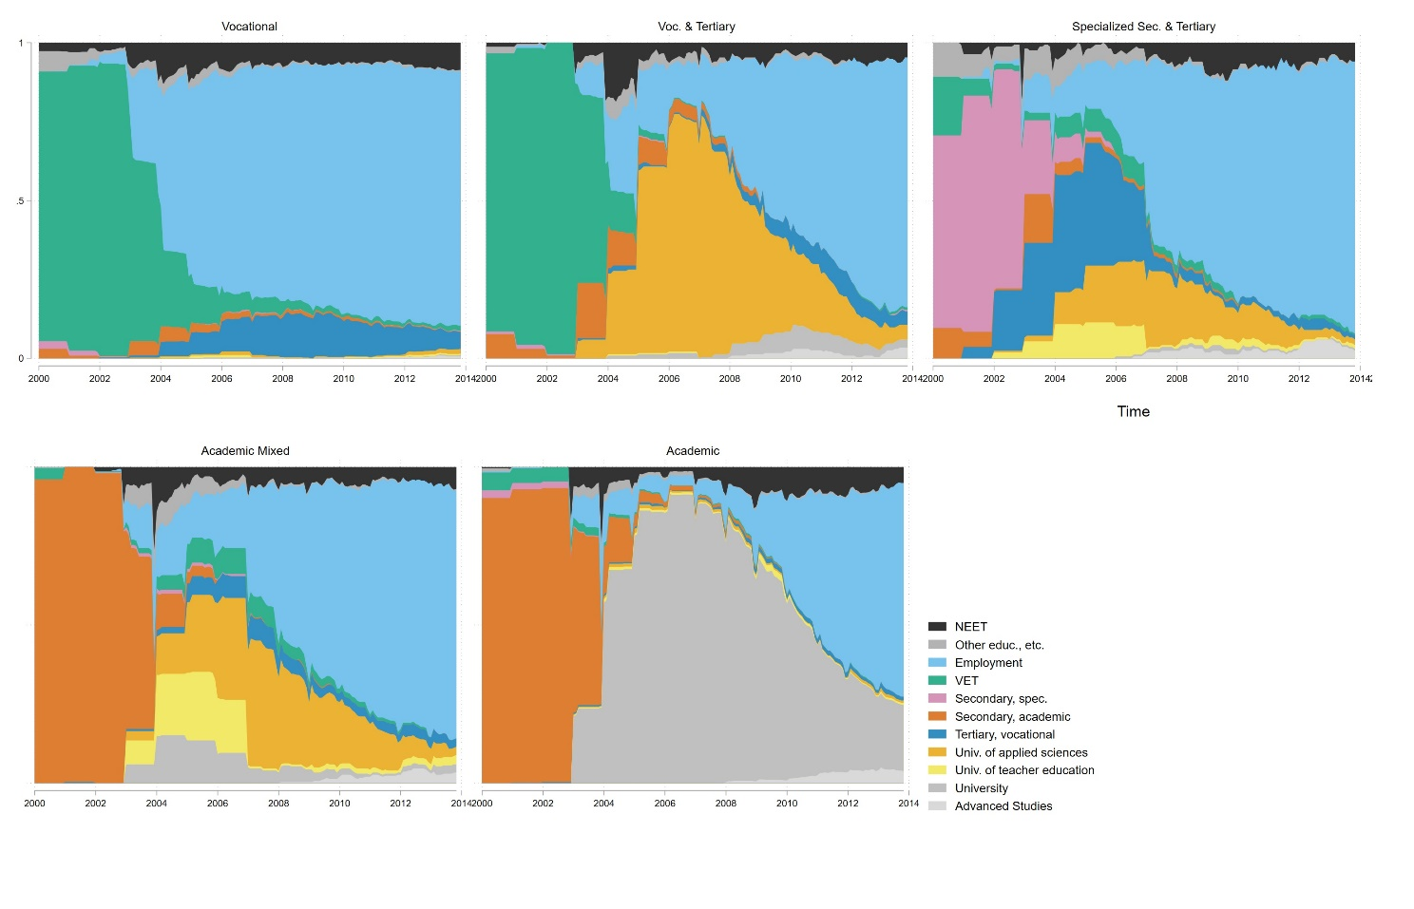

**Figure 2:** Clusters of educational trajectories.

Figure 3 shows the distribution of men and women in those clusters. The first cluster contains mainly the trajectories of a vocational education on secondary level followed by employment or to a lesser extent, by subsequent vocational education on tertiary level. This is the most common educational pathway of this cohort, especially for men. The second cluster differs in the respect that the vocational education on secondary level is followed by tertiary education, mainly at a university of applied sciences. Men also more frequently follow this educational path than women do. The third cluster is the smallest one in terms of the number of students who chose this educational pathway and it is even more gendered than the previous two: The specialised secondary education that is followed mainly by tertiary vocational education or university of applied sciences and to a lesser extent university of teacher education is almost uniquely feminine. The main reason for that is that these specialised secondary schools mainly prepare for a tertiary education in the health care sector. The final two clusters contain the trajectories starting with high school, followed either by university of applied sciences or by university. While the latter is balanced by gender, in the former, that also contains universities of teacher education, women are overrepresented.

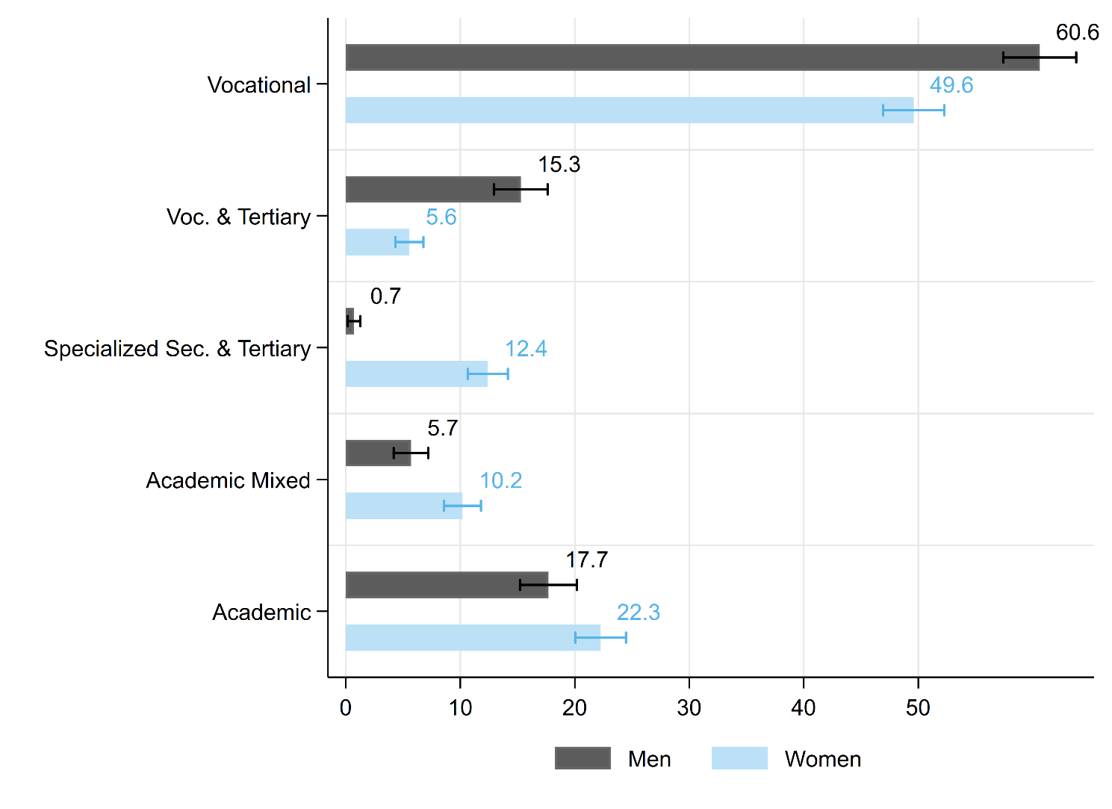**Figure 3:** Distribution of men and women in the educational clusters

In the next step, we analyse whether social origin and gender have an effect on the probability of belonging to a certain educational cluster. The results are displayed in Figure 4/Figure 5 and Table 3/Table 4 (in the annex). We find a strong effect of social origin. Pupils growing up in families with a lower socioeconomic status have a significantly higher probability of belonging to the vocational cluster. In other words, the lower the parental ISEI the higher the chance that they enter the labour market after their vocational training and do not pursue further education. An equally clear effect we find for cluster five: The higher the parental ISEI, the higher the probability that the students graduate high school and enter university. We also find a moderate effect of social origin on the probability of belonging to the vocational & tertiary and to the mixed academic cluster. Conversely, only the probability of belonging to the specialized secondary & tertiary cluster is not affected by social origin. These effects are being mitigated slightly when controlling for reading, mathematics/science skills, and the effect on the probability of belonging to the second cluster loses statistical significance. Boys have a higher probability of belonging to one of the two vocational clusters, while girls are overrepresented in the specialised secondary and the mixed academic cluster. Both of them lead to rather female typical occupations in the health and social sector and to teaching. In sum, we find somewhat different trajectories for boys and girls, depending on the parental social status. While boys from lower to middle social backgrounds more often start their secondary education with vocational education, girls more often attend general secondary schools. Among the pupils from higher social backgrounds, the gender difference in educational trajectory is less pronounced.

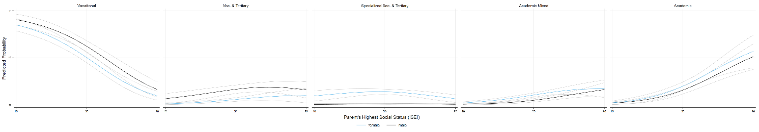**Figure 4:** Probabilities of belonging to a certain cluster, by social origin and gender, total effect

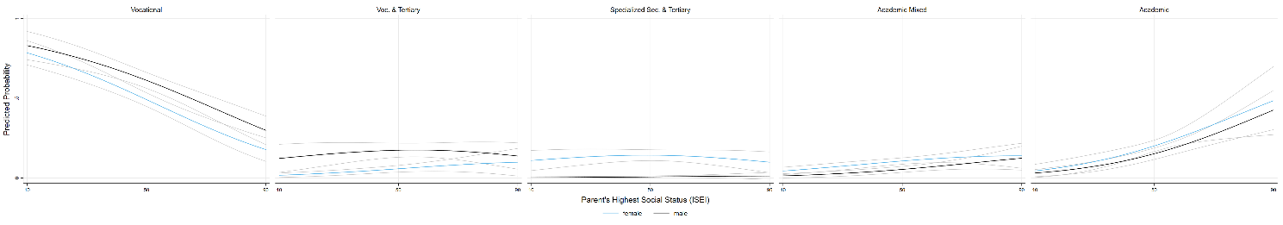**Figure 5:** Probabilities of belonging to a certain cluster, by social origin and gender, total effect, net of reading and mathematics/science skills

In the following steps of our analyses we estimate the effects of school trajectory, social origin and gender on the persons own labour market outcomes in 2014 at the age of about 30 years. We measure labour market outcomes in two ways: The persons own ISEI and their salary. For each outcome, we calculate two models, in the first we estimate the total effect of social status and gender without controlling for educational trajectory. In the second model, we introduce the educational clusters. For the estimation of the social status, we additionally control whether the measurement of the respondents ISEI is current (in 2014) or earlier, in case the person was not working in 2014. For the estimation of the salary, we control if the person is self-employed or not.

We find a strong effect of the parents social status on the respondents own social status, displayed in the left graph of Figure 6 (see also Table 5 in the appendix). The effects of the parents social status is similar for men and women, interaction effects between gender and social origin are not significant. For both genders, the effect is stronger at the lower range of the parental ISEI. It is mitigated to a certain extent when we include the clusters of educational trajectories in the model, but remains significant (right graph of Figure 6). In this model, in the top range of the parental ISEI the effect disappears and the curve becomes flat or even turns slightly downwards for women. However, it must be noted that the confidence intervals at the ends of the curve become quite large.

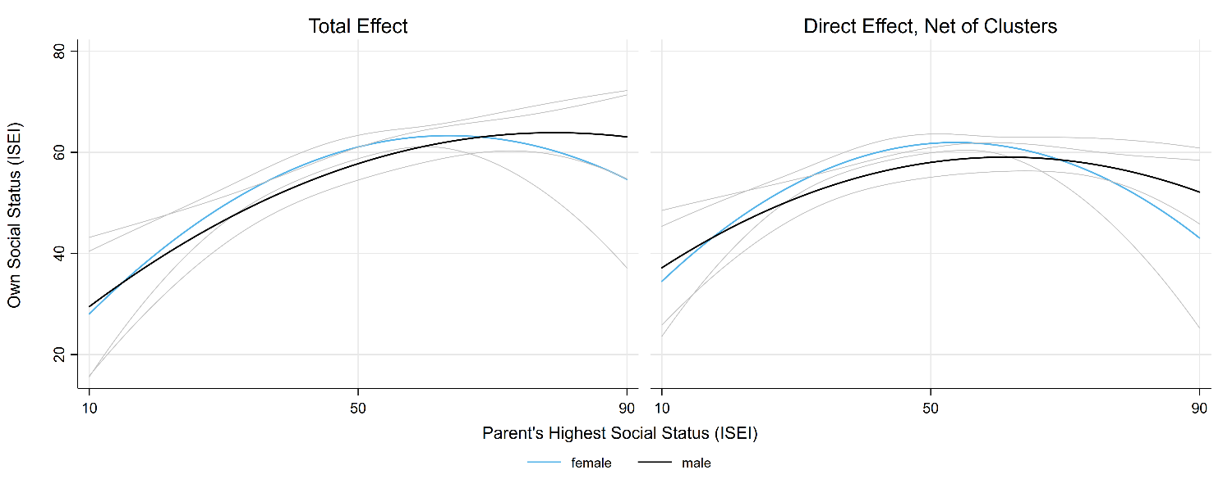**Figure 6:** Effects on social status (ISEI) in 2014 (age ~30)

We conducted the same analyses for the salary at age 30. The left-hand graph of Figure 7 shows again the total effect (see also **Table 6** in the appendix). On the right-hand side, the direct effect, controlling for educational trajectories is displayed. We found that the effect of social origin is much stronger for women than for men. When we control for the educational pathway, the effect disappears for men, but not for women. We suppose that this is due to the specificity of the Swiss dual educational system: In many occupations, a tertiary degree following vocational education, can lead to a rather high salary. This concerns mainly male dominated occupations, such as, for example, banking, IT or technical professions. It seems that especially women with parents having a low socioeconomic status end up in low paid jobs, even when the educational trajectory is controlled for. It is an open question, if this direct effect of parental social status on own social status and on the salary would entirely disappear if the horizontal class and gender segregation would be modelled more in detail.

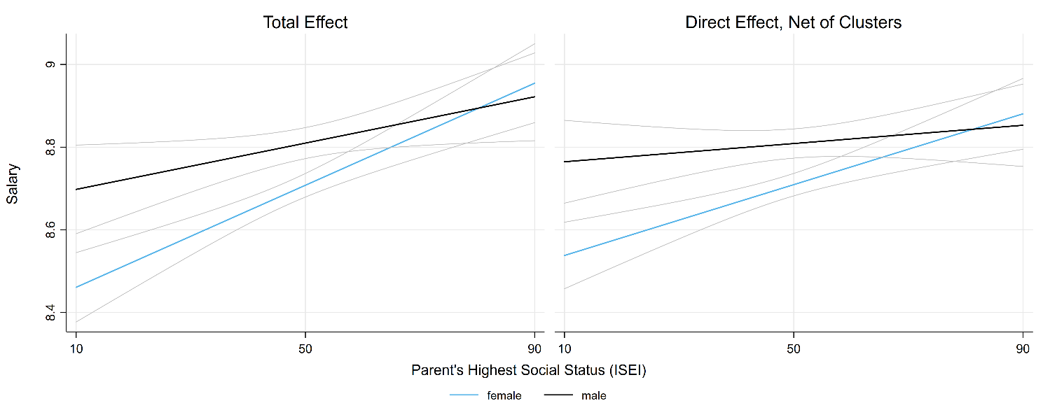**Figure 7:** Effects on log salary in 2014 (age ~30)

Our final analyses concern the effects of educational pathways on status and salary (Table 7 in the appendix). Figure 8 displays the predicted ISEI by educational cluster. Persons directly entering the labour market after their apprenticeship or pursuing some tertiary vocational education (vocational cluster) by far reach the lowest social status. This is true for men and women. The differences in social status between the other educational clusters are less pronounced. Persons following general secondary education and university (academic cluster) reach the highest status at age 30. Men who complete vocational and tertiary education at the university of applied sciences are reaching a similarly high status.

Salary differences between different educational clusters are less pronounced (see Figure 9). We find the within cluster gender difference clearly more pronounced in terms of salary than in terms of status. On the other hand, there are two clusters that yield comparatively low salaries, the vocational and the specialized secondary & tertiary cluster. In the two vocational clusters, we find a significant gender gap, with men reaching markedly higher salaries than women do.

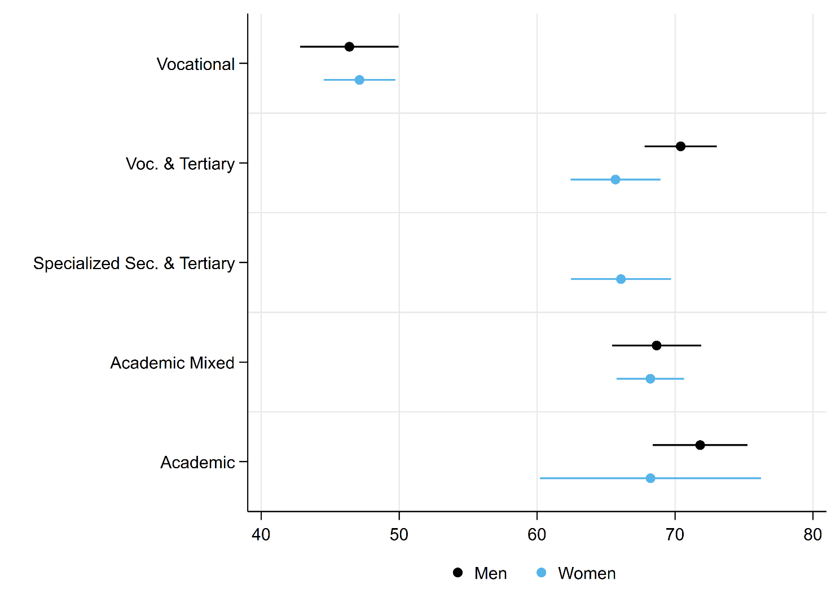**Figure 8:** Predicted Social Status (ISEI) by Educational Cluster

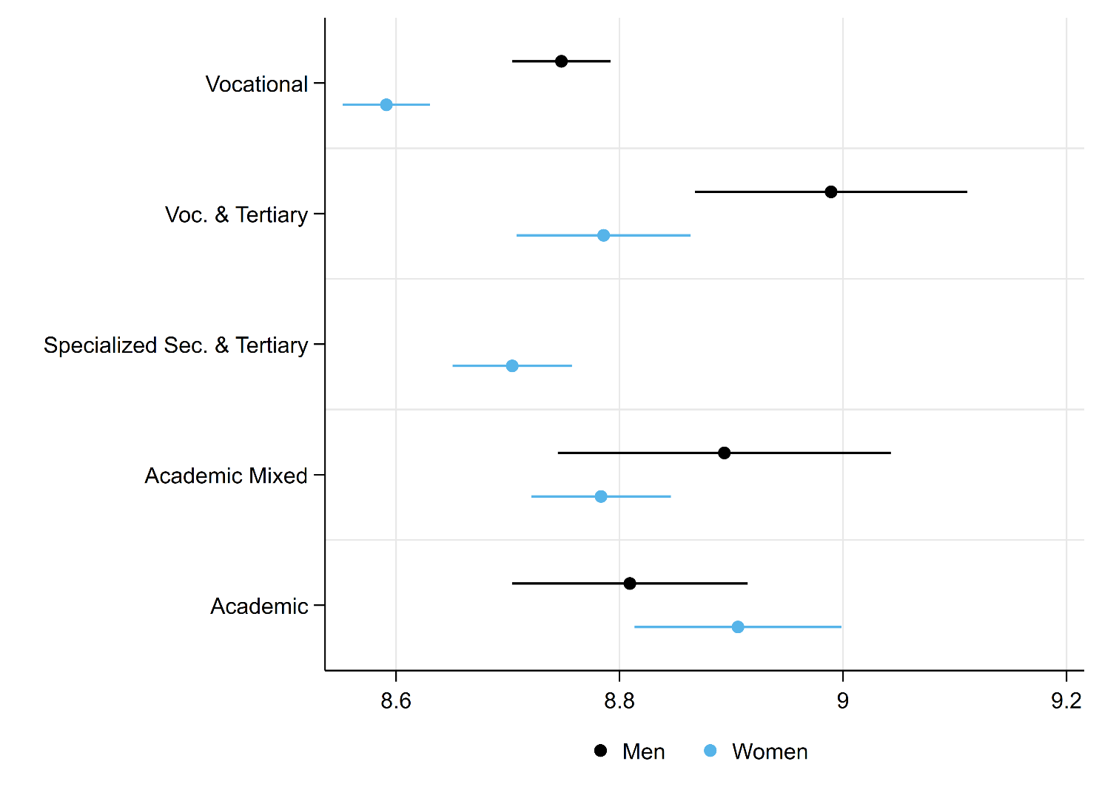**Figure 9:** Predicted Log Salary by Educational Cluster

**5. Robustness Checks**

To check the robustness of our results, we conducted some additional analyses. In particular, we sought to rule out two different sources of biases. First, while the cluster solutions found by the dynamic hamming procedure is plausible, it could be argued that it does not clearly enough separate individuals who entered the labour marked directly after vocational education training and did not pursue any tertiary education from those with at least some tertiary education. In order to check this, we pre-defined a cluster with all individuals without any tertiary education and used optimal matching for forming four clusters with the remaining respondents (Figure 10 in the annex). This alters the size of the two vocational clusters (the second cluster becomes the biggest), but does not substantially change the results of the regressions (results not shown). Second, at age 30, especially persons who completed tertiary education are in a critical phase of their occupational career. Few year more of experience in the labour market could increase their salary significantly. In order to take this into account, we re-estimated the models predicting log salaries based on a restricted sample including only the respondents who completed their education at least two years previously (see the left panel of **Table 8** in the appendix). Using the restricted sample increases the gender gap and decreases the effect of the parental social status of men compared to the original model. Finally, as self-declarations of salaries are sometimes unrealistically low or high, in our last model, we excluded the highest and the lowest percentage (see right panel of **Table 8** in the appendix). This does not substantially alter our results.

**6. Conclusions**

In our analyses, we tried to show a global picture of the intersectional effects of gender and social status on the educational trajectories and on subsequent labour market outcomes. The combination of sequence analyses and regressions allowed us to reduce the complexity of individual life courses and use them in explanatory models without sacrificing the strength of the panel data. We found that first, gender and social origin distinctly influence performance in reading, mathematics/science tasks at the end of compulsory school. Second, boys and girls from different social family backgrounds follow varying educational trajectories. Boys are being overrepresented in the vocational tracks, while girls more often attend general secondary schools. We suspect that one important reason is gender-typical choice of occupation. In the vocational track, the range of male dominated occupations is much vaster and it subsequently offers better labour market prospects. Female dominated jobs that offer some labour market prospects usually require general secondary education. The choice of educational pathway is consequential for subsequent labour market success. We show that men and women following the academic track, as well as men following the vocational & tertiary track reach the highest status, while individuals in the vocational cluster by far reach the lowest status. In terms of salary, we find a strong gender pay gap, especially within the vocational clusters. Despite the crucial importance of educational trajectories, effects of social origin remain significant and especially women face a “class pay gap”.

**Acknowledgements**

**Conflict of Interests**

**References**

Adams, R. & Wu, M. (2003). *PISA Programme for international student assessment (PISA) PISA 2000 technical report*: oecd Publishing.

Allmendinger, J., Ebner, C., & Nikolai, R. (2010). Soziologische Bildungsforschung. In R. Tippelt & B. Schmidt (Eds.), *Handbuch Bildungsforschung* (3. ed., pp. 1058). Wiesbaden: VS Verlag für Sozialwissenschaften | Springer Fachmedien.

Becker, R. (2007). „Das katholische Arbeitermädchen vom Lande“ – Ist die Bildungspolitik ein Opfer einer bildungssoziologischen Legende geworden? In C. Crotti, P. Gonon, & W. Herzog (Eds.), *Pädagogik und Politik: historische und aktuelle Perspektiven: Festschrift für Fritz Osterwalder* (pp. 386). Bern Stuttgart Wien: Haupt Verlag.

Becker, R., Haunberger, S., & Schubert, F. (2010). Studienfachwahl als Spezialfall der Ausbildungsentscheidung und Berufswahl. *Zeitschrift für Arbeitsmarktforschung, 42*(4), 292-310.

Becker, R. & Lauterbach, W. (2010). *Bildung als Privileg: Erklärungen und Befunde zu den Ursachen der Bildungsungleichheit* (4. ed.). Wiesbaden: VS Verlag für Sozialwissenschaften.

Becker, R. & Müller, W. (2011). Bildungsungleichheiten nach Geschlecht und Herkunft im Wandel. In A. Hadjar (Ed.), *Geschlechtsspezifische Bildungsungleichheiten* (pp. 253). Wiesbaden: VS Verlag für Sozialwissenschaften.

Blau, F. D. & Kahn, L. M. (2017). The gender wage gap: Extent, trends, and explanations. *Journal of Economic Literature, 55*(3), 789-865.

Boudon, R. (1974). *Education, opportunity and social inequality: changing prospects in western society*. New York: John Wiley & Sons Inc.

Bourdieu, P. & Passeron, J.-C. (1971). *Die Illusion der Chancengleichheit: Untersuchungen zur Soziologie des Bildungswesens am Beispiel Frankreichs*. Stuttgart: Klett.

Breen, R. & Goldthorpe, J. H. (1997). Explaining educational differentials towards a formal rational action theory. *Rationality and society, 9*(3), 275-305.

Breen, R., Luijkx, R., Müller, W., & Pollak, R. (2009). Long-term trends in educational inequality in Europe: Class inequalities and gender differences. *European Sociological Review, 26*(1), 31-48.

Buchmann, C. & DiPrete, T. A. (2006). The growing female advantage in college completion: the role of family background and academic achievement. *American Sociological Review, 71*(4), 515-541.

Buchmann, M. & Kriesi, I. (2012). Geschlechtstypische Berufswahl: Begabungszuschreibungen, Aspirationen und Institutionen. In *Soziologische Bildungsforschung* (pp. 256-280): Springer.

Charles, M. (2011). A world of difference: international trends in women’s economic status. *Annual Review of Sociology, 37*, 355-371.

Charles, M. & Bradley, K. (2002). Equal but separate? A cross-national study of sex segregation in higher education. *American Sociological Review, 67*(4), 573-599.

Charles, M. & Bradley, K. (2009). Indulging our gendered selves? Sex segregation by field of study in 44 countries. *American Journal of Sociology, 114*(4), 924-976.

Dahrendorf, R. (1965). *Bildung ist Bürgerrecht: Plädoyer für eine aktive Bildungspolitik*. Hamburg: Rohwolt.

DiPrete, T. A. & Buchmann, C. (2013). *The rise of women: The growing gender gap in education and what it means for American schools*: Russell Sage Foundation.

Eagly, A. H. & Diekman, A. B. (2006). What is the problem? Prejudice as an attitude-in-context. In J. F. Dovidio, P. Glick, & L. A. Rudman (Eds.), *On the nature of prejudice: Fifty years after Allport* (pp. 465).

Eagly, A. H. & Karau, S. J. (2002). Role congruity theory of prejudice toward female leaders. *Psychological review, 109*(3), 573.

Eagly, A. H. & Sczesny, S. (2008). Stereotypes about women, men and leaders: Have time changed? In M. K. Barreto, M. K. Ryan, & M. T. Schmitt (Eds.), *The glass ceiling in the 21st century: Understanding barriers to gender equality* (pp. 21‐47). Washington: American Psychological Association.

England, P. (2010). The gender revolution uneven and stalled. *Gender & Society, 24*(2), 149-166.

Entwisle, D. R., Alexander, K. L., & Olson, L. S. (2007). Early schooling: the handicap of being poor and male. *Sociology of Education, 80*(2), 114-138.

Erikson, R. & Jonsson, J. O. (1996). *Can education be equalized? The Swedish case in comparative perspective*: Westview Press.

Geißler, R. (2005). Die Metamorphose der Arbeitertochter zum Migrantensohn. Zum Wandel der Chancenstruktur im Bildungssystem nach Schicht, Geschlecht, Ethnie und deren Verknüpfungen. In P. A. Berger (Ed.), *Institutionalisierte Ungleichheiten: wie das Bildungswesen Chancen blockiert* (pp. 256). Weinheim und München: Juventa.

Glaesser, J. & Cooper, B. (2012). Gender, parental education, and ability: their interacting roles in predicting GCSE success. *Cambridge Journal of Education, 42*(4), 463-480.

Glauser, D. (2015). *Berufsausbildung oder Allgemeinbildung: soziale Ungleichheiten beim Übergang in die Sekundarstufe II in der Schweiz*.

Gottburgsen, A. & Gross, C. (2012). Welchen Beitrag leistet „Intersektionalität“ zur Klärung von Kompetenzunterschieden bei Jugendlichen? In R. Becker & H. Solga (Eds.), *Soziologische Bildungsforschung* (pp. 503).

Imdorf, C. & Hupka-Brunner, S. (2015). Gender differences at labor market entry in Switzerland. In H.-P. Blossfeld, J. Skopek, M. Triventi, & S. Buchholz (Eds.), *Gender, education and employment: an international comparison of school-to-work transitions*: Edward Elgar Publishing.

Imdorf, C., Koomen, M., Murdoch, J., & Guégnard, C. (2017). Do vocational pathways improve higher education access for women and men from less privileged social backgrounds? A comparison of vocational tracks to higher education in France and Switzerland. *Rassegna italiana di Sociologia, 58*(2), 283-314.

Imdorf, C., Sacchi, S., Wohlgemuth, K., Cortesi, S., & Schoch, A. (2014). How cantonal education systems in Switzerland promote gender-typical school-to-work transitions. *Schweizerische Zeitschrift für Soziologie/Swiss journal of sociology/Revue suisse de sociologie, 40*(2), 175-196.

McCall, L. (2005). The complexity of intersectionality. *Signs, 30*(3), 1771-1800.

Mood, C. (2017). More than money: social class, income, and the intergenerational persistence of advantage. *Sociological Science, 4*, 263-287.

Paulus, W. & Blossfeld, H.-P. (2007). Schichtspezifische Präferenzen oder sozioökonomisches Entscheidungskalkül? Zur Rolle elterlicher Bildungsaspirationen im Entscheidungsprozess beim Übergang von der Grundschule in die Sekundarstufe. *Zeitschrift für Pädagogik, 53*(4), 491-508.

Peisert, H. (1967). *Soziale Lage und Bildungschancen in Deutschland*. München: Piper.

Reimer, D. & Pollak, R. (2005). *The impact of social origin on the transition to tertiary education in West Germany 1983 and 1999*. Arbeitspapiere - Mannheimer Zentrum für Europäische Sozialforschung. Universität Mannheim.

Rivera, L. A. & Tilcsik, A. (2016). Class advantage, commitment penalty: the gendered effect of social class signals in an elite labor market. *American Sociological Review, 81*(6), 1097-1131.

Schwiter, K., Hupka-Brunner, S., Wehner, N., Huber, E., Kanji, S., Maihofer, A., & Bergman, M. M. (2014). Warum sind Pflegefachmänner und Elektrikerinnen nach wie vor selten? Geschlechtersegregation in Ausbildungs-und Berufsverlaufen junger Erwachsener in der Schweiz. *Schweizerische Zeitschrift für Soziologie, 40*(3), 401-428.

Strand, S. (2014). Ethnicity, gender, social class and achievement gaps at age 16: Intersectionality and ‘Getting it’for the white working class. *Research Papers in Education, 29*(2), 131-171.

van de Werfhorst, H. G. (2002). A detailed examination of the role of education in intergenerational social-class mobility. *Social Science Information, 41*(3), 407-438.

Warm, T. A. (1989). Weighted likelihood estimation of ability in item response theory. *Psychometrika, 54*(3), 427-450.

**Annex.**

**Table 1:** Descriptive statistics

|  |  |  |  |  |  |  |
| --- | --- | --- | --- | --- | --- | --- |
|  | **Men** |  |  | **Women** |  |  |
|  | **N** | **Mean** | **St.Dev.** | **N** | **Mean** | **St.Dev.** |
| Warm estimate in reading | 905 | 503.4681 | 85.84859 | 1351 | 529.3798 | 83.4235 |
| Warm estimate in mathematics | 506 | 564.4188 | 87.70875 | 764 | 538.6016 | 87.68012 |
| Warm estimate in science | 503 | 526.1381 | 87.66748 | 728 | 515.5228 | 85.63865 |
| Warm estimate in mathematics/science | 804 | 549.4268 | 87.16704 | 1186 | 528.8242 | 84.43665 |
| Highest parental ISEI | 887 | 49.84882 | 16.46005 | 1337 | 50.02997 | 17.13414 |
| Vocational | 907 | .6061268 | .4888769 | 1353 | .4959834 | .5001687 |
| Voc. & Tertiary | 907 | .152859 | .36005 | 1353 | .0555577 | .2291502 |
| Specialized Sec. & Tertiary | 907 | .0071143 | .0840919 | 1353 | .1239999 | .3297033 |
| Academic Mixed | 907 | .0569109 | .2318001 | 1353 | .1019172 | .3026512 |
| Academic | 907 | .1769891 | .38187 | 1353 | .2225419 | .4161069 |
| Current ISEI | 872 | 55.79286 | 20.74112 | 1295 | 57.73193 | 19.29024 |
| Std. monthly gross salary | 761 | 7121.236 | 3619.881 | 1136 | 6575.126 | 3662.414 |

Source: PISA 2000 and TREE waves 1-9 (weighted)

**Table 2:** Effects on reading and mathematics/science skills (OLS coefficients)

|  |  |  |  |  |
| --- | --- | --- | --- | --- |
|  | **Warm estimate in reading** | | **Warm estimate in mathematics/science** | |
| Women | 18.86** | (7.097) | -22.84* | (9.502) |
| Highest parental ISEI (centered) | 1.805*** | (0.338) | 1.240*** | (0.273) |
| Women*Highest parental ISEI (centered) | -0.536 | (0.445) | 0.0274 | (0.353) |
| Highest parental ISEI (centered)*Highest parental ISEI (centered) | -0.0501** | (0.0155) | -0.0143 | (0.0145) |
| Women*Highest parental ISEI (centered)*Highest parental ISEI (centered) | 0.0209 | (0.0221) | 0.00393 | (0.0177) |
| Constant | 522.4*** | (5.835) | 557.5*** | (8.591) |
| Observations | 2221 |  | 1960 |  |

Standard errors in parentheses

* p < 0.05, ** p < 0.01, *** p < 0.001

Source: PISA 2000 and TREE waves 1-9 (weighted)

**Table 3:** Probability of belonging to a certain educational cluster (average marginal effects based on multinomial logistic regression)

|  |  |  |  |  |  |
| --- | --- | --- | --- | --- | --- |
|  | **Vocational** | **Voc. & Tertiary** | **Specialized Sec. & Tertiary** | **Academic Mixed** | **Academic** |
| Women | -0.106*** | -0.0976*** | 0.118*** | 0.0466*** | 0.0393 |
|  | (0.0320) | (0.0193) | (0.0134) | (0.0130) | (0.0216) |
| Highest parental ISEI | -0.0105*** | 0.00147** | -0.000181 | 0.00218*** | 0.00702*** |
|  | (0.000698) | (0.000478) | (0.000380) | (0.000375) | (0.000781) |
| Observations | 2224 | 2224 | 2224 | 2224 | 2224 |

Standard errors in parentheses

* p < 0.05, ** p < 0.01, *** p < 0.001

Source: PISA 2000 and TREE waves 1-9 (weighted)

**Table 4:** Probability of belonging to a certain educational cluster (average marginal effects based on multinomial logistic regression)

|  |  |  |  |  |  |
| --- | --- | --- | --- | --- | --- |
|  | **Vocational** | **Voc. & Tertiary** | **Specialized Sec. & Tertiary** | **Academic Mixed** | **Academic** |
| Women | -0.108*** | -0.103*** | 0.122*** | 0.0442** | 0.0451 |
|  | (0.0288) | (0.0196) | (0.0164) | (0.0145) | (0.0233) |
| Highest parental ISEI | -0.00705*** | 0.000600 | -0.0000470 | 0.00125** | 0.00524*** |
|  | (0.000621) | (0.000491) | (0.000430) | (0.000412) | (0.000952) |
| Warm estimate in reading | -0.00156*** | 0.000119 | 0.0000589 | 0.000472*** | 0.000913*** |
|  | (0.000229) | (0.000140) | (0.000130) | (0.000123) | (0.000189) |
| Warm estimate in mathematics/science | -0.00121*** | 0.000264* | -0.000193 | 0.000329** | 0.000809*** |
|  | (0.000207) | (0.000129) | (0.000114) | (0.000111) | (0.000130) |
| Observations | 1960 | 1960 | 1960 | 1960 | 1960 |

Standard errors in parentheses

* p < 0.05, ** p < 0.01, *** p < 0.001

Source: PISA 2000 and TREE waves 1-9 (weighted)

**Table 5:** Effects on social status (ISEI) (OLS coefficients)

|  |  |  |  |  |
| --- | --- | --- | --- | --- |
|  | **Current ISEI** | | | |
| Women | -5.159 | (14.74) | -9.952 | (12.76) |
| Highest parental ISEI | 1.137** | (0.401) | 1.022** | (0.343) |
| Women*Highest parental ISEI | 0.427 | (0.619) | 0.522 | (0.560) |
| Highest parental ISEI*Highest parental ISEI | -0.00718* | (0.00360) | -0.00835** | (0.00307) |
| Women*Highest parental ISEI*Highest parental ISEI | -0.00514 | (0.00617) | -0.00602 | (0.00578) |
| Not current | -2.990 | (2.100) | -1.835 | (2.586) |
| Voc. & Tertiary |  |  | 20.56*** | (1.738) |
| Specialized Sec. & Tertiary |  |  | 19.01*** | (1.848) |
| Academic Mixed |  |  | 21.21*** | (1.655) |
| Academic |  |  | 22.84*** | (1.680) |
| Voc. & Tertiary*Not current |  |  | 7.890 | (5.773) |
| Specialized Sec. & Tertiary*Not current |  |  | -2.118 | (6.210) |
| Academic Mixed*Not current |  |  | -3.445 | (5.822) |
| Academic*Not current |  |  | -3.390 | (4.376) |
| Constant | 18.96 | (10.49) | 19.49* | (8.805) |
| Observations | 2124 |  | 2124 |  |

Standard errors in parentheses

* p < 0.05, ** p < 0.01, *** p < 0.001

Source: PISA 2000 and TREE waves 1-9 (weighted)

**Table 6:** Effects on log salary (OLS coefficients)

|  |  |  |  |  |
| --- | --- | --- | --- | --- |
|  | **Log std. monthly gross salary** | | | |
| Women | -0.269*** | (0.0807) | -0.263*** | (0.0764) |
| Highest parental ISEI | 0.00280* | (0.00127) | 0.00110 | (0.00119) |
| Women*Highest parental ISEI | 0.00337* | (0.00157) | 0.00318* | (0.00145) |
| Self-employed | -0.0906 | (0.0838) | -0.0743 | (0.0863) |
| Voc. & Tertiary |  |  | 0.209*** | (0.0409) |
| Specialized Sec. & Tertiary |  |  | 0.0725* | (0.0330) |
| Academic Mixed |  |  | 0.129*** | (0.0321) |
| Academic |  |  | 0.172*** | (0.0372) |
| Constant | 8.672*** | (0.0670) | 8.685*** | (0.0634) |
| Observations | 1860 |  | 1860 |  |

Standard errors in parentheses

* p < 0.05, ** p < 0.01, *** p < 0.001

Source: PISA 2000 and TREE waves 1-9 (weighted)

**Table 7:** Effects of educational clusters on social status and salary by gender (OLS coefficients)

|  |  |  |  |  |
| --- | --- | --- | --- | --- |
|  | **Current ISEI** | | **Log std. monthly gross salary** | |
|  | **Men** | **Women** | **Men** | **Women** |
| Voc. & Tertiary | 24.02*** | 18.56*** | 0.241*** | 0.194*** |
|  | (2.341) | (2.210) | (0.0663) | (0.0449) |
| Specialized Sec. & Tertiary | 12.41 | 18.96*** | -0.124 | 0.113** |
|  | (8.632) | (2.154) | (0.220) | (0.0341) |
| Academic Mixed | 22.27*** | 21.09*** | 0.146 | 0.192*** |
|  | (2.445) | (1.732) | (0.0792) | (0.0369) |
| Academic | 25.43*** | 21.10*** | 0.0613 | 0.315*** |
|  | (2.529) | (4.280) | (0.0581) | (0.0509) |
| Not current | -2.991 | -2.388 |  |  |
|  | (3.066) | (2.763) |  |  |
| Self-employed |  |  | -0.0223 | -0.0493 |
|  |  |  | (0.114) | (0.119) |
| Constant | 46.52*** | 47.27*** | 8.748*** | 8.593*** |
|  | (1.857) | (1.344) | (0.0227) | (0.0204) |
| Observations | 872 | 1295 | 761 | 1136 |

Standard errors in parentheses

* p < 0.05, ** p < 0.01, *** p < 0.001

Source: PISA 2000 and TREE waves 1-9 (weighted)

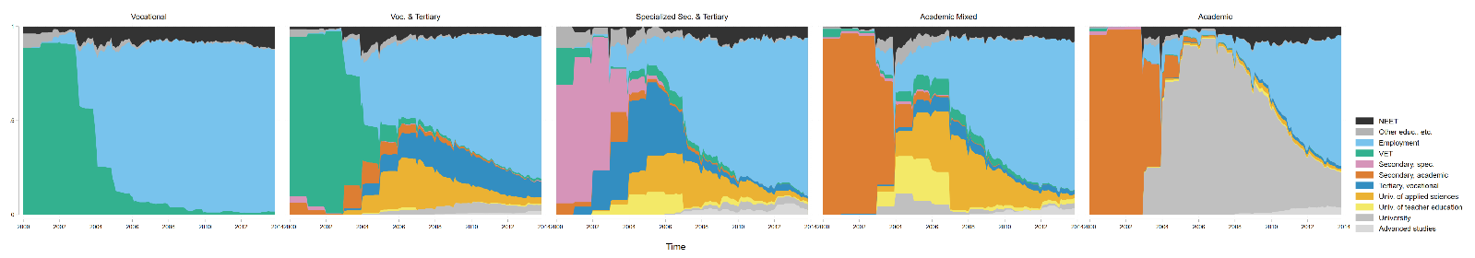**Figure 10:** Clusters of educational trajectories, solution with a separate cluster for VET & employment

**Table 8:** Effects of educational clusters on social status and salary by gender (OLS coefficients)

|  |  |  |  |  |  |  |  |  |
| --- | --- | --- | --- | --- | --- | --- | --- | --- |
|  | **Log std. monthly gross salary** | | | | | | | |
|  | **End of education at least 2 years ago** | | |  | **Exclusion of the lowest and highest 1%** | | | |
| Women | -0.362*** | (0.0856) | -0.350*** | (0.0778) | -0.245** | (0.0751) | -0.243*** | (0.0699) |
| Highest parental ISEI | 0.00151 | (0.00121) | -0.000286 | (0.00106) | 0.00228* | (0.00109) | 0.000824 | (0.00106) |
| Women*Highest parental ISEI | 0.00496** | (0.00163) | 0.00458** | (0.00146) | 0.00295* | (0.00138) | 0.00278* | (0.00125) |
| Self-employed | -0.0800 | (0.0888) | -0.0618 | (0.0896) | -0.0577 | (0.0781) | -0.0408 | (0.0796) |
| Voc. & Tertiary |  |  | 0.176*** | (0.0254) |  |  | 0.170*** | (0.0236) |
| Specialized Sec. & Tertiary |  |  | 0.0656* | (0.0310) |  |  | 0.0786* | (0.0316) |
| Academic Mixed |  |  | 0.150*** | (0.0339) |  |  | 0.143*** | (0.0307) |
| Academic |  |  | 0.202*** | (0.0299) |  |  | 0.144*** | (0.0303) |
| Constant | 8.744*** | (0.0689) | 8.762*** | (0.0609) | 8.689*** | (0.0625) | 8.701*** | (0.0587) |
| Observations | 1591 |  | 1591 |  | 1829 |  | 1829 |  |

Standard errors in parentheses

* p < 0.05, ** p < 0.01, *** p < 0.001

Source: PISA 2000 and TREE waves 1-9 (weighted)

Adams, R., & Wu, M. (2003). *PISA Programme for international student assessment (PISA) PISA 2000 technical report*: oecd Publishing.

Allmendinger, J., Ebner, C., & Nikolai, R. (2010). Soziologische Bildungsforschung. In R. Tippelt & B. Schmidt (Eds.), *Handbuch Bildungsforschung* (3. ed., pp. 1058). Wiesbaden: VS Verlag für Sozialwissenschaften | Springer Fachmedien.

Becker, R. (2007). „Das katholische Arbeitermädchen vom Lande“ – Ist die Bildungspolitik ein Opfer einer bildungssoziologischen Legende geworden? In C. Crotti, P. Gonon, & W. Herzog (Eds.), *Pädagogik und Politik: historische und aktuelle Perspektiven: Festschrift für Fritz Osterwalder* (pp. 386). Bern Stuttgart Wien: Haupt Verlag.

Becker, R., Haunberger, S., & Schubert, F. (2010). Studienfachwahl als Spezialfall der Ausbildungsentscheidung und Berufswahl. *Zeitschrift für Arbeitsmarktforschung, 42*(4), 292-310.

Becker, R., & Lauterbach, W. (2010). *Bildung als Privileg: Erklärungen und Befunde zu den Ursachen der Bildungsungleichheit* (4. ed.). Wiesbaden: VS Verlag für Sozialwissenschaften.

Becker, R., & Müller, W. (2011). Bildungsungleichheiten nach Geschlecht und Herkunft im Wandel. In A. Hadjar (Ed.), *Geschlechtsspezifische Bildungsungleichheiten* (pp. 253). Wiesbaden: VS Verlag für Sozialwissenschaften.

Blau, F. D., & Kahn, L. M. (2017). The gender Wage Gap: Extent, Trends, and Explanations. *Journal of Economic Literature, 55*(3), 789-865.

Boudon, R. (1974). *Education, opportunity and social inequality: changing prospects in western society*. New York: John Wiley & Sons Inc.

Bourdieu, P., & Passeron, J.-C. (1971). *Die Illusion der Chancengleichheit: Untersuchungen zur Soziologie des Bildungswesens am Beispiel Frankreichs*. Stuttgart: Klett.

Breen, R., & Goldthorpe, J. H. (1997). Explaining educational differentials towards a formal rational action theory. *Rationality and society, 9*(3), 275-305.

Breen, R., Luijkx, R., Müller, W., & Pollak, R. (2009). Long-term trends in educational inequality in Europe: Class inequalities and gender differences. *European Sociological Review, 26*(1), 31-48.

Brzinsky-Fay, C., & Kohler, U. (2010). New developments in sequence analysis. *Sociological Methods & Research, 38*(3), 359-364.

Buchmann, C., & DiPrete, T. A. (2006). The growing female advantage in college completion: the role of family background and academic achievement. *American Sociological Review, 71*(4), 515-541.

Buchmann, M., & Kriesi, I. (2012). Geschlechtstypische Berufswahl: Begabungszuschreibungen, Aspirationen und Institutionen. In *Soziologische Bildungsforschung* (pp. 256-280): Springer.

Charles, M. (2011). A world of difference: international trends in women’s economic status. *Annual Review of Sociology, 37*, 355-371.

Charles, M., & Bradley, K. (2009). Indulging our gendered selves? Sex segregation by field of study in 44 countries. *American Journal of Sociology, 114*(4), 924-976.

Dahrendorf, R. (1965). *Bildung ist Bürgerrecht: Plädoyer für eine aktive Bildungspolitik*. Hamburg: Rohwolt.

DiPrete, T. A., & Buchmann, C. (2013). *The Rise of Women: The Growing Gender Gap in Education and what it Means for American Schools*: Russell Sage Foundation.

Eagly, A. H., & Diekman, A. B. (2006). What is the Problem? Prejudice as an Attitude-in-Context. In J. F. Dovidio, P. Glick, & L. A. Rudman (Eds.), *On the Nature of Prejudice: Fifty Years after Allport* (pp. 19-35). Malden, Oxford, Carlton: Blackwell Publishing.

Eagly, A. H., & Karau, S. J. (2002). Role Congruity Theory of Prejudice Toward Female Leaders. *Psychological review, 109*(3), 573.

Eagly, A. H., & Sczesny, S. (2008). Stereotypes about women, men and leaders: Have time changed? In M. K. Barreto, M. K. Ryan, & M. T. Schmitt (Eds.), *The glass ceiling in the 21st century: Understanding barriers to gender equality* (pp. 21‐47). Washington: American Psychological Association.

England, P. (2010). The gender revolution uneven and stalled. *Gender & Society, 24*(2), 149-166.

Entwisle, D. R., Alexander, K. L., & Olson, L. S. (2007). Early schooling: the handicap of being poor and male. *Sociology of Education, 80*(2), 114-138.

Erikson, R., & Jonsson, J. O. (1996). *Can education be equalized? The Swedish case in comparative perspective*: Westview Press.

Geißler, R. (2005). Die Metamorphose der Arbeitertochter zum Migrantensohn. Zum Wandel der Chancenstruktur im Bildungssystem nach Schicht, Geschlecht, Ethnie und deren Verknüpfungen. In P. A. Berger (Ed.), *Institutionalisierte Ungleichheiten: wie das Bildungswesen Chancen blockiert* (pp. 256). Weinheim und München: Juventa.

Glaesser, J., & Cooper, B. (2012). Gender, parental education, and ability: their interacting roles in predicting GCSE success. *Cambridge Journal of Education, 42*(4), 463-480.

Glauser, D. (2015). *Berufsausbildung oder Allgemeinbildung: soziale Ungleichheiten beim Übergang in die Sekundarstufe II in der Schweiz*.

Gomensoro, A., Meyer, T., Hupka-Brunner, S., Jann, B., Müller, B., Oesch, D., . . . Scharenberg, K. (2017). *Employment Situation at Age Thirty. Results Update of the Swiss Panel Survey TREE*. Retrieved from

Gottburgsen, A., & Gross, C. (2012). Welchen Beitrag leistet „Intersektionalität“ zur Klärung von Kompetenzunterschieden bei Jugendlichen? In R. Becker & H. Solga (Eds.), *Soziologische Bildungsforschung* (pp. 503).

Halpin, B. (2010). Optimal matching analysis and life-course data: the importance of duration. *Sociological Methods & Research, 38*(3), 365-388.

Halpin, B. (2017). SADI: Sequence analysis tools for Stata. *Stata Journal, 17*(3), 546-572.

Imdorf, C., & Hupka-Brunner, S. (2015). Gender differences at labor market entry in Switzerland. In H.-P. Blossfeld, J. Skopek, M. Triventi, & S. Buchholz (Eds.), *Gender, education and employment: an international comparison of school-to-work transitions* (pp. 267–286). Cheltenham and Northampton: Edward Elgar Publishing.

Imdorf, C., Koomen, M., Murdoch, J., & Guégnard, C. (2017). Do vocational pathways improve higher education access for women and men from less privileged social backgrounds? A comparison of vocational tracks to higher education in France and Switzerland. *Rassegna italiana di Sociologia, 58*(2), 283-314.

Imdorf, C., Sacchi, S., Wohlgemuth, K., Cortesi, S., & Schoch, A. (2014). How cantonal education systems in Switzerland promote gender-typical school-to-work transitions. *Swiss Journal of Sociology, 40*(2), 175-196.

Lesnard, L. (2006). *Optimal matching and social sciences*. Retrieved from

Lesnard, L. (2010). Setting cost in optimal matching to uncover contemporaneous socio-temporal patterns. *Sociological Methods & Research, 38*(3), 389-419. doi:10.1177/0049124110362526

Mood, C. (2017). More than money: social class, income, and the intergenerational persistence of advantage. *Sociological Science, 4*, 263-287.

Paulus, W., & Blossfeld, H.-P. (2007). Schichtspezifische Präferenzen oder sozioökonomisches Entscheidungskalkül? Zur Rolle elterlicher Bildungsaspirationen im Entscheidungsprozess beim Übergang von der Grundschule in die Sekundarstufe. *Zeitschrift für Pädagogik, 53*(4), 491-508.

Peisert, H. (1967). *Soziale Lage und Bildungschancen in Deutschland*. München: Piper.

Reimer, D., & Pollak, R. (2005). *The impact of social origin on the transition to tertiary education in West Germany 1983 and 1999*. Arbeitspapiere - Mannheimer Zentrum für Europäische Sozialforschung. Universität Mannheim.

Rivera, L. A., & Tilcsik, A. (2016). Class advantage, commitment penalty: the gendered effect of social class signals in an elite labor market. *American Sociological Review, 81*(6), 1097-1131.

Sacchi, S. (2011). Construction of TREE panel weights. *Documentation for the panel waves from 2000 to 2010, 2011*.

Schwiter, K., Hupka-Brunner, S., Wehner, N., Huber, E., Kanji, S., Maihofer, A., & Bergman, M. M. (2014). Warum sind Pflegefachmänner und Elektrikerinnen nach wie vor selten? Geschlechtersegregation in Ausbildungs-und Berufsverlaufen junger Erwachsener in der Schweiz. *Schweizerische Zeitschrift für Soziologie, 40*(3), 401-428.

Strand, S. (2014). Ethnicity, gender, social class and achievement gaps at age 16: Intersectionality and ‘Getting it’for the white working class. *Research Papers in Education, 29*(2), 131-171.

van de Werfhorst, H. G. (2002). A detailed examination of the role of education in intergenerational social-class mobility. *Social Science Information, 41*(3), 407-438.

Warm, T. A. (1989). Weighted likelihood estimation of ability in item response theory. *Psychometrika, 54*(3), 427-450.

1. For younger cohorts this is less so the case. In 2002, the healthcare assistant apprenticeship has been created and it is now an important route to nursing.